**Changing User Stories after sponsor meeting 02/11/2022**

As an initial set of user stories, we opted to have an arrow point to a location in AR:

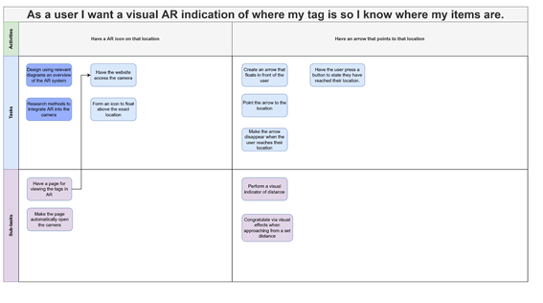

This is with having a tag at a location. In addition to this, we determined the method of managing these tags as a list of them in another page:

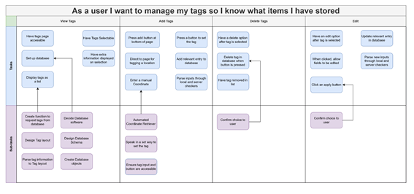

Where, we determined ‘edit’ as the only method to change the tags’ location. Moreso, we failed to include the idea of ‘Picking up’ and ‘Placing down’ tags. Thus, if the user were to reach their tag and pick up that object, there would be no explicit status of ‘Picked up’, and instead would be up to implementation, maybe deleting the tag outright.

This also removes the idea of Placing down.

After the meeting with our sponsor, the idea of placing and picking was brought up, so we decided to overhaul some of our user stories to reflect this:

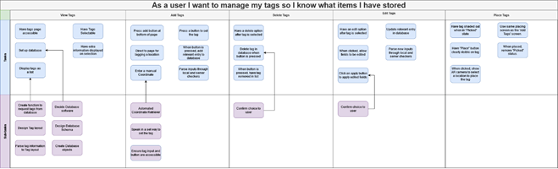

In the page where you view tags, we opted to have a new status for the tags – them being ‘Picked up’. In this state, the tag would be shaded out, and the only option you’d have would be to place the tag back down.

The edit tags are still here, but it will be relegated to more rare situations.

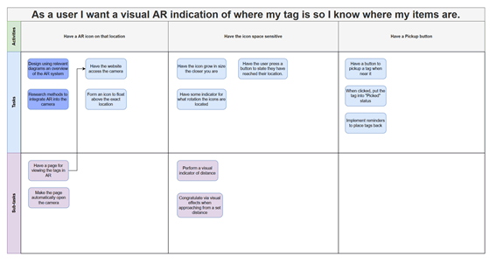

In AR mode, we have also added the user stories for having a pickup button. This would be activated when the user is close to a tag, and thus when they pick up the item, the system can reflect that with the ‘Picked up’ state.

**Changing User Stories after meeting 09/11/2022**

We had a meeting deciding what our first sprint should focus on, and we decided on a short 1 week sprint to research the most pivotal AR implementation, and also create the foundation of the website and database.

With this, we found that we had no explicit user story to create the website, so we edited the story map to reflect this change:

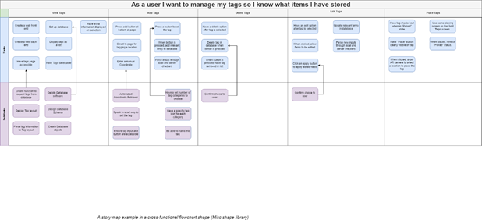

In view tags, two new user stories were added to reflect our process.

**Sprint 1 (09/11/2022 -> 16/11/2022)**

In this sprint, we decided to first create the foundation of our project. Thus, it was made to be shorter than normal.

The user stories assigned were:

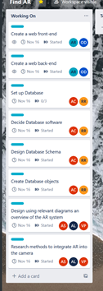

And we split the team into 3 subteams, with one working on designing/researching how the use AR in websites. Another team was set on setting up a website that everyone can develop on in the future, and the last was assigned the task of designing some extensible database that reflects our current goal of a viewable list of tags and a user login system.

Most of the user stories were in the ‘View Tags’ Epic:

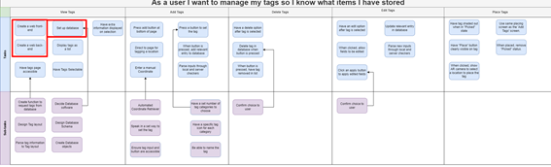

And the ‘Have an AR icon on that location” Epic:

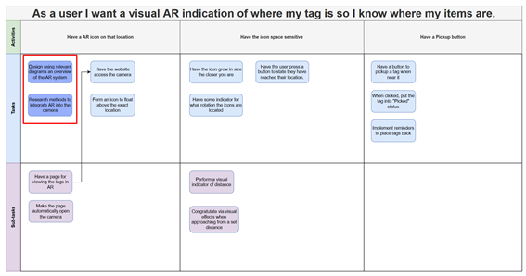

We have also set up the sub-teams to reflect the skillset of everyone. The website sub-team includes Alfie, who has moderate experience in web technologies, and Oliver, whose skillset leans more on data interpretation.

Our AR team is the largest, as no one in our team has any substantial experience in AR. This is the primary reason we have dedicated a week to just research.

The database team consists of Alan and Rodion, and both of their experience stems from first year modules. No one in our team has more extensive experience in database design, so there was no calculated choice here.

**Sub-Team Website Creation user stories:**

For this subteam, with Alfie and Olly, we were unable to progress much due to being unable to access IBM services. During this we with the team lead set up a meeting with our sponsor and got everyone to sign up to IBM services as the pre-requisite to access the services.

Thus, these user stories have been moved to the next sprint to do.

**Sprint 1 Retrospective/ Sprint 2 (17/11/2022 -> 1/12/2022)**

We held a retrospective on Thursday 17/11/2022 to go over what everyone achieved, what was difficult, and what we need to change going forward.

The “Set up a database” sub-team with Rodion and Aidan managed to set up and create a schema, achieving all of their user stories. They done this using IBM’s services which we were allowed to use.

However, with this, we found that we needed to change our ‘View Tags’ Epic to accommodate for the next step, integrating and connecting that database to a web-server:

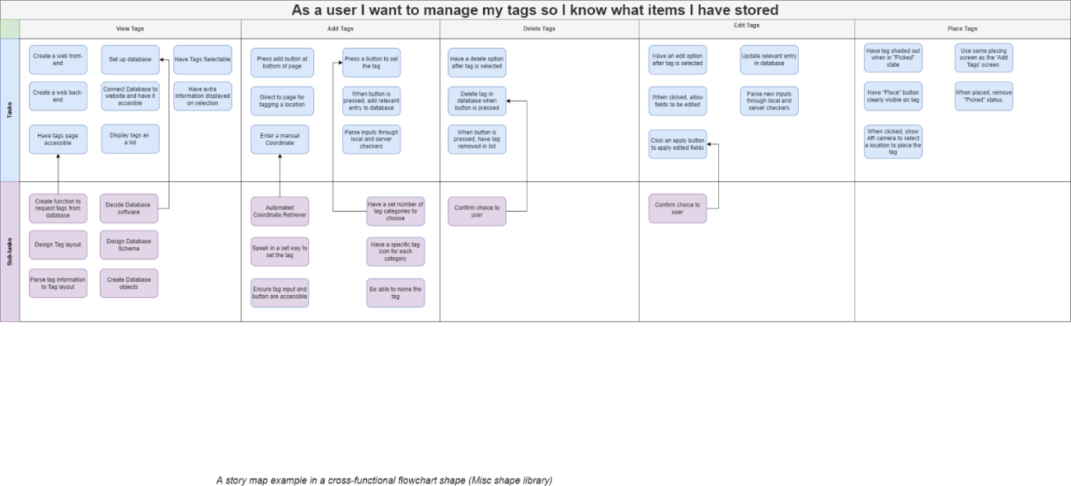

We assigned “Connect database to website and have it accessible” to the story map, as it makes more sense in the context of this retrospective.

The AR side of the project was also researched, and the sub-team of Alan, Vishal and Alex found that a lot of the work has already been done in AR.js. However, as there was no server to actively test it on, it was difficult to create concrete diagrams to outline the system, so the sub-team could only finish half the sprint user stories.

Through this we discussed to include a new user-story to ‘integrate AR.JS’ into the soon-to-be webserver, as a more specific variation of the problem: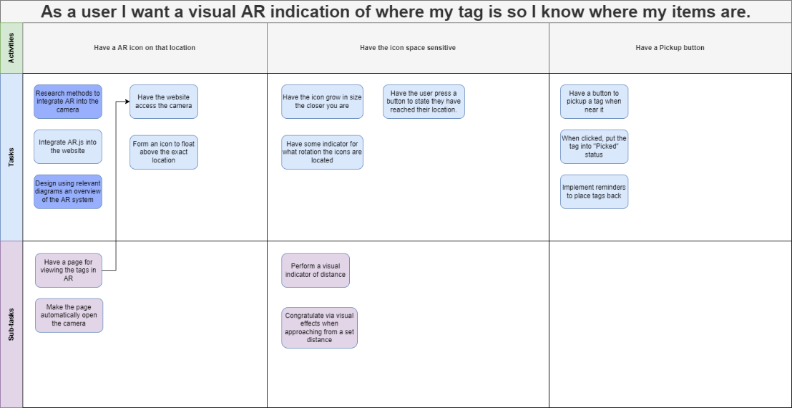

For the website creation, none of the user stories were able to be completed, but this was due to areas outside the project, so nothing could be done to rectify it.

With this, we assigned new user-stories to be completed:

